|  |  |
| --- | --- |
|  | Year 12 Specialist  TEST 1  Friday 9 February 2018  TIME: 5 mins reading 40 minutes working Classpads **allowed!**  37 marks 7 Questions |

Name:_______________________________

Teacher: ____________________________

**Note: All part questions worth more than 2 marks require working to obtain full marks.**

Some useful Formulae



**Note: All part questions worth more than 2 marks require working to obtain full marks.**

Q1) ( 2, 2, 2, 2 & 1 = 9 marks)

If  and  determine exactly:

1. 
2. 
3. 
4. 
5. What do you notice about (c) and (d)?

Q2 ( 2 & 2 = 4 marks)

Express each of the following into Cartesian form, 

1. 
2. 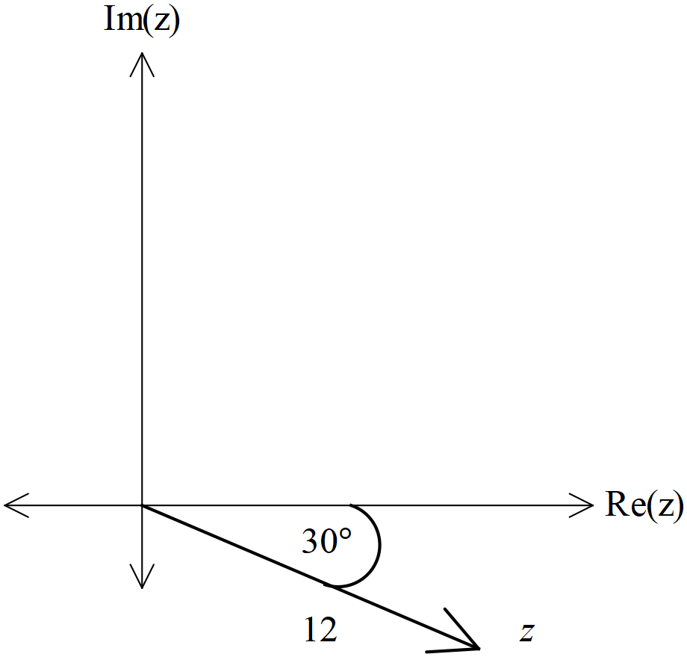

Q4 (3 marks)

Determine z in polar form given that w and zw have been drawn below.

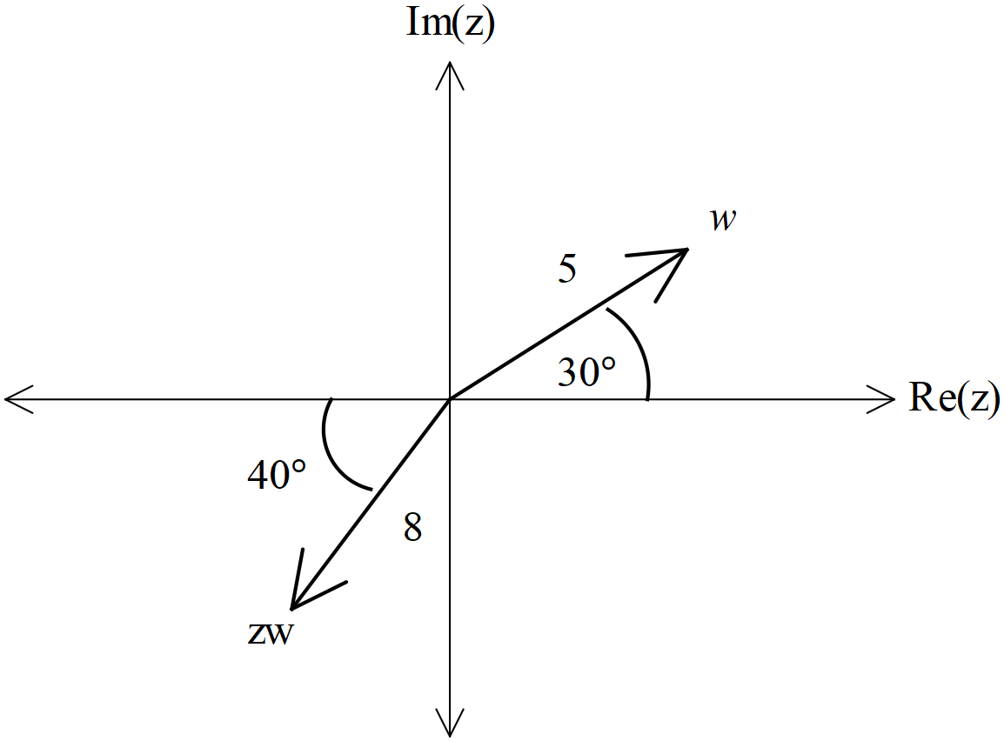

Q5 ( 5, 3 & 3 =11 marks)

1. Determine all the roots of the equation , expressing them all in polar form with  and 
2. Plot the roots on the diagram below. (Note: each minor angle is  radians.)

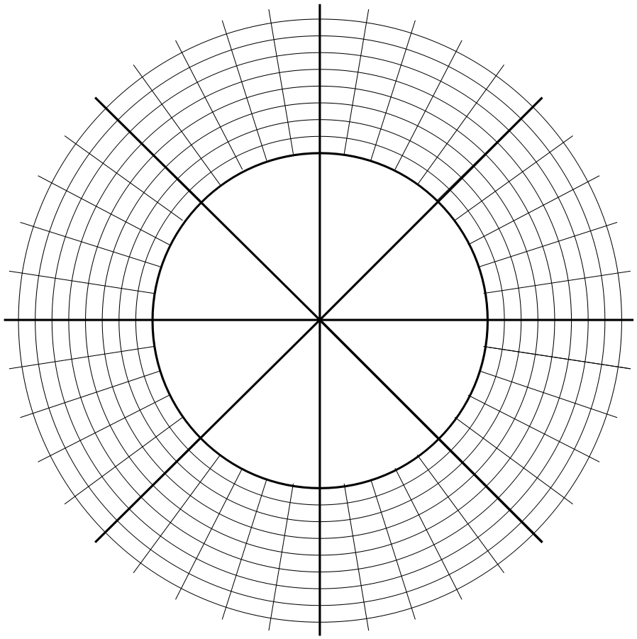

1. The roots form the vertices of a pentagon. Determine the value for the perimeter of the pentagon to two decimal places.

Q6 (5 marks)

Determine, **using de Moivre’s theorem**, an expression for  in terms of  only.

{Hint: start with }

Q7 (5 marks)

Consider the points A and B in the complex plane. The perpendicular bisector of the line AB is represented by 

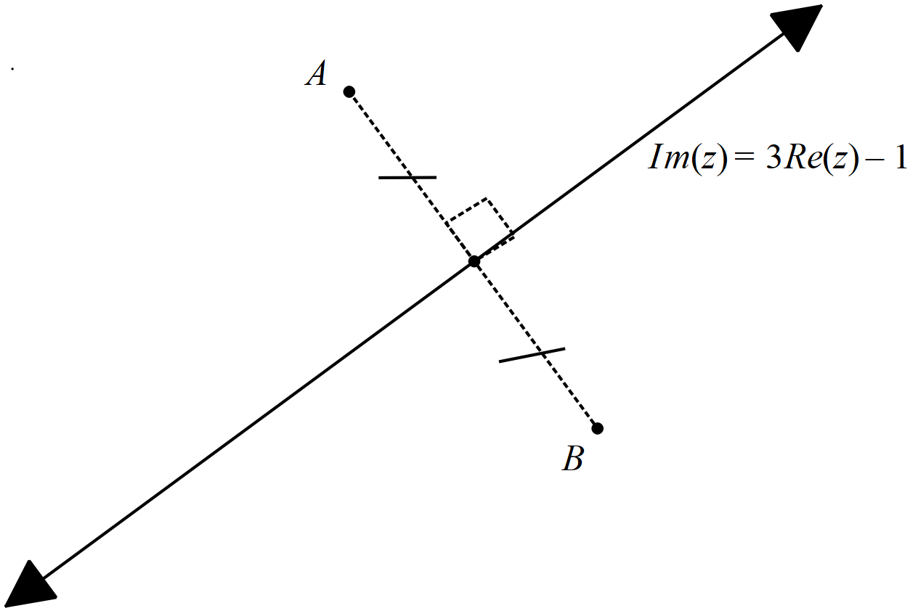

If point A is  and point B is  in the complex plane, determine the values of the constants c and d.